Overview:

During the 2024 stimulations there were three wells equipped with downhole instruments for microseismic monitoring: 58-32, 78B-32 and 56-32.

Initial planing:
Well 58-32: 12-level geochain (SLB)
Well 78B-32: 8-level geochain (GES)
Well 56-32: Single-level PSS tool (GES)

Deviations:
Well 58-32:
→ 12-level geochain pulled after 3 days of recording (2024-04-06)
→ missing data in between, SLB report pending
→ replaced by DAS wireline on 2024-04-17 (not included in this data set)

Well 78B-32:
→ 8-level geochain failed on 2024-04-18, pulled on 2024-04-19
→ geochain replaced by single PSS tool on 2024-04-20 ~00:00
(at level 1 position in raw data)
→ missing/empty data in between (see log below)
→ receiver 8 written to receiver 7 position in between (see log below)

Well 56-32:
→ Single-level PSS tool failed/replaced between 2024-04-05 and 2024-04-07
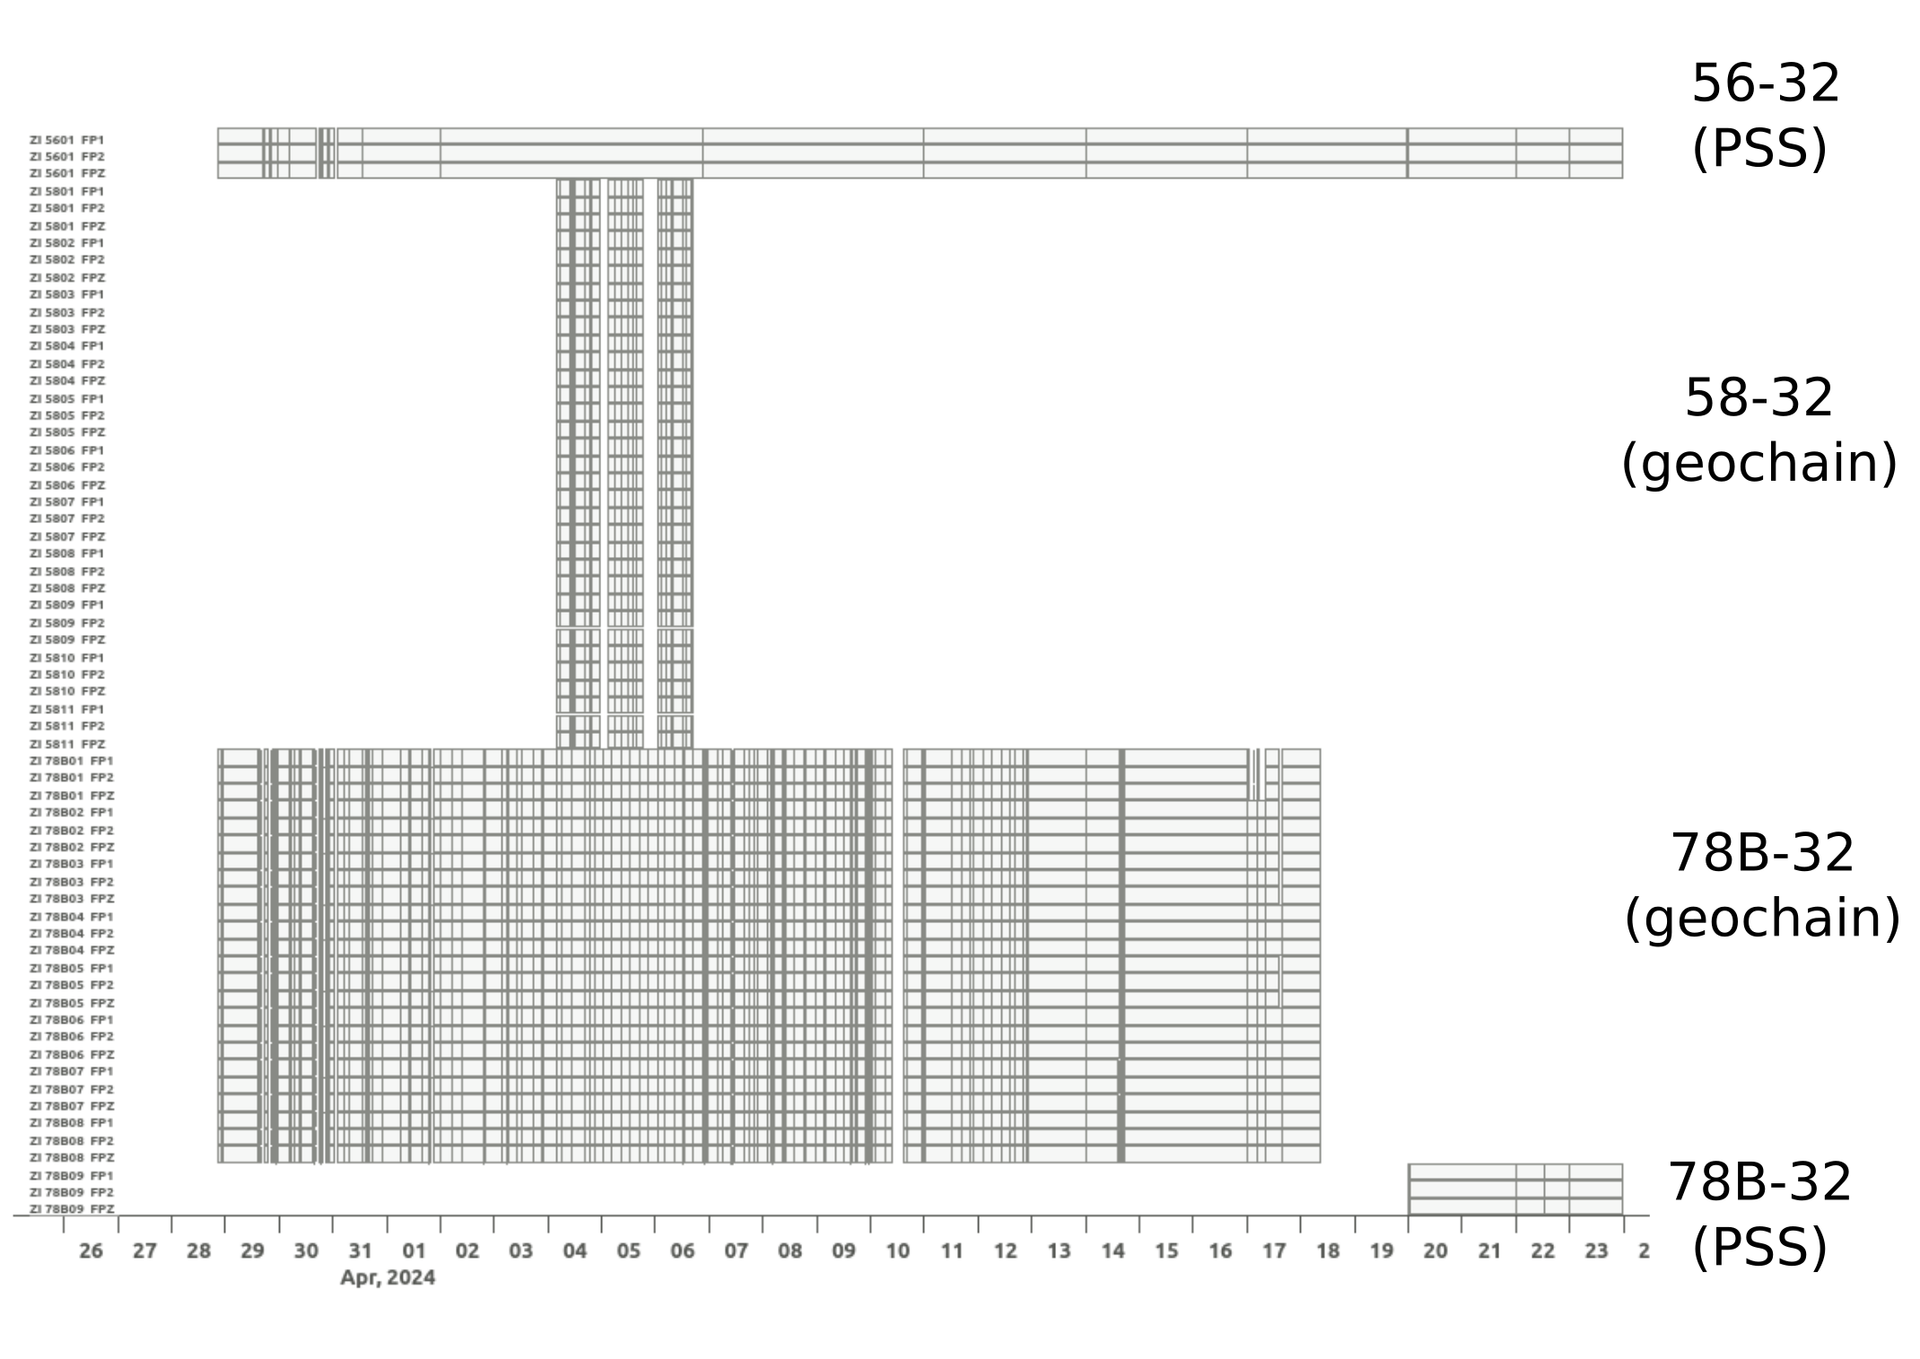
Fig 1: Downhole data availability for the 2024 stimulations at Utah FORGE. The data availability shown here does not necessarily guaranty uncorrupted data (see failure log below)

Data delivery:

raw
→ segy/seg2 files as delivered by contractors/partners

mseeds
→ mini-seed files with metadata matching the provided receiver files
→ naming convention: increasing receiver index from top to botttom
→ horizontal components have arbitrary orientations, N and E components not rotated

metadata
→ additional data files such as logs, coordinates, etc.

Reference of local coordinate system:

well 16A, ground level (lat = 38.50402147, lon=-112.8963897, elevation=1650 m)

The receiver coordinates given in the receiver_ft.csv and receiver_meter.csv are relatibe to the same reference. Deviating elevations/depths given in FORGE16AandB_StimulationSensors.xlsx might have other local references, e.g., the ground level at the given well.

Time:

All seismic traces are in UTC.

Field notes (Outages and possible timing errors) for wells 56-32 and 78B-32:

→ from GES field notes (local time) → here converted to UTC
→ full log in local time in spreadsheet delivered with the data

2024-03-31
15:30 Clock time on the PSS made an error switching due to a summertime clock change.
Merged PSS and Geochain files 07:00-15:30 likely to be mis-matched by an hour
this is not worth correcting as we are only testing at the moment

2024-04-05
20:19 Around this time the PSS in 56 failed.

2024-04-07:
16:00 Replaced the PSS tool
17:40 56 is detecting events again

2024-04-10
15:00 Geochain has failed overnight. Restart around 15:30
23:10 Geochain off to investigate the clock problem
23:35 Geochain on

2024-04-11
00:02 Geochain off. It failed for an unknown reason but manually re-started OK
00:18 Geochain On.
22:14 Re-clamped groups 1, 5 and 8 of 78B

2024-04-12
22:45 Geochain ping test. All channels are normal

2024-04-14
20:27 Geochain tool 7 failed. Re-started but is noisy
Various fails and re-starts
Discovered that the tool 8 data is written to traces 19, 20 and 21 when tool 7 fails (this is referred to as "bypass" in Avalon software)
23:39 Tool 7 is back on.

2024-04-15
Water dripping slightly from 78B

2024-04-18
08:40 Geochain in 78B failed overnight. Reported by Ben K. from the UK
Merger stopped due to missing Geochain files
Re-triggered the data with only one group and two traces required ie the PSS

2024-04-19
01:00 Finished pulling the Geochain

2024-04-21
15:00 Tools are running

2024-04-25
15:00 Pulling 78B. Turned it off the trigger

Instrument information for wells 56-32 and 78B-32 (GES):

→ see spreadsheet delivered with the data for response infromation
→ trace amplitudes are positive for energy propagating in the directions up, +1, +2, with 1 and 2 being the arbitrary orientations of the two horizontal channels
→ sampling rate 4000Hz

Field notes (Outages and possible timing errors) for well 58-32 (SLB):

→ Data from well 58-32 (SLB) were not integrated in real-time downhole monitoring
→ The timing was not synchronized with other deployments
→ There are timing errors between geophone groups

→ final report of SLB still pending

Instrument information for wells 58-32 (SLB):

→ sampling rate 2000Hz
→ SLB report pending

Data usage from 58-32 (SLB) only recommended after extensive quality control!

